# COMP3506 Revision Sheet

Contents

COMP3506 Revision Sheet 1

Contents 1

Week 1 3

Theoretical Analysis Steps: 3

Pseudo Code Details: 3

Counting Primitive Operations 4

The seven functions that often appear in algorithm analysis: 4

Big-O Notation: 5

Big-O Rules 5

Big- $Ω$ Notation 5

Big- $θ$ Notation 5

Week 2 6

Recursion 6

Selection Sort 6

Analysis of Recursive Algorithms 7

Divide and Conquer Paradigm 7

Merge-Sort 8

Quick-Sort 10

Week 3 12

Bucket Sort 12

Radix Sort 13

Linear Data Structure 14

Stacks 15

Queues 16

Week 4 16

Array List 16

Amortised Time 16

Positional Lists 17

Iterators 17

Tree Basics 18

Tree Traversals 18

Binary Tree 19

Week 5 20

Priority Queue 20

Heaps 21

Week 6 24

Hash Tables 24

Binary Search Trees 25

Week 7 26

AVL Trees 26

Splay Trees 27

2-4 Trees 28

Red Black Trees 29

(a, b) Trees 31

B-Trees 32

Week 8 32

Graphs 32

Depth First Search (DFS) 37

Breadth-First Search 38

Directed Graphs 40

Week 9 42

Weighted Graph 42

Dijkstra’s Algorithm 42

Minimum Spanning Trees 43

Kruskal’s Algorithm 46

Week 10 48

Brute-Force Pattern Matching 48

Boyer-Moore 49

Knuth-Morris-Pratt (KMP) Algorithm 51

Tries 52

Compressed Tries 53

Text Compression 55

Huffman’s Algorithm 56

## Week 1

Space complexity is where we count the number of memory cells.

Time complexity is where we count the number of operations.

### Theoretical Analysis Steps:

1. Express algorithm as pseudo-code
2. Count primitive operations
3. Describe algorithm as f(n)
4. Perform asymptotic analysis

### Pseudo Code Details:

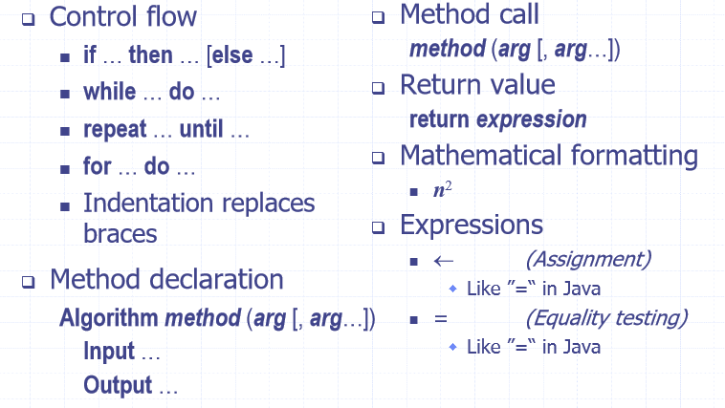

Example:

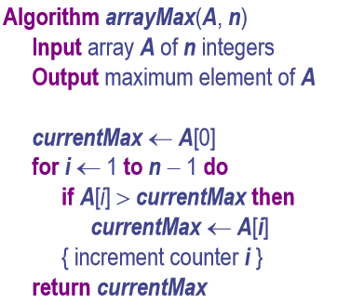

### Counting Primitive Operations

To count primitive operations, count every step the code must do. For example:

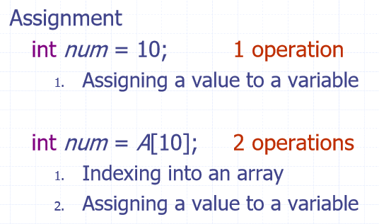 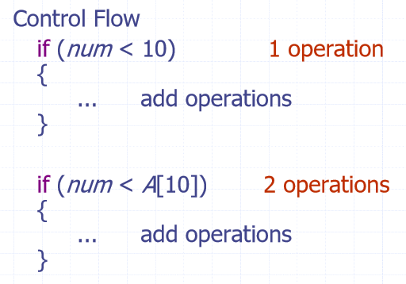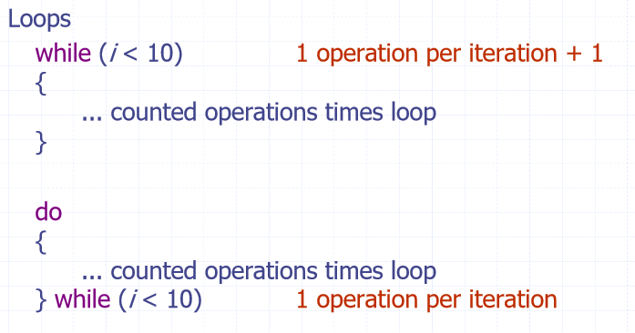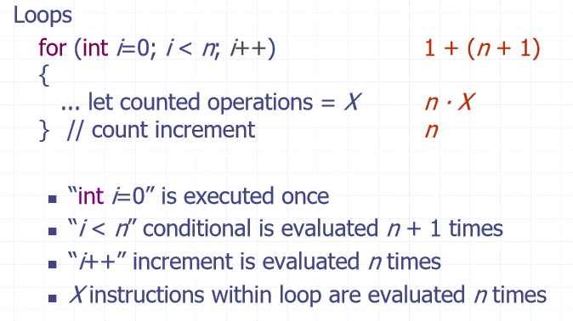

### The seven functions that often appear in algorithm analysis:

1. Constant: 1
2. Logarithmic: $log⁡(n)$
3. Linear: n
4. N-log-N: $nlog(n)$
5. Quadratic: $n^{2}$
6. Cubic: $n^{3}$
7. Exponential: $2^{n}$

### Big-O Notation:

* Big-O notation describes an upper bound on a function
* $f\left(n\right)$ is $O\left(g\left(n\right)\right)$ if $f\left(n\right)$ is asymptotically less than or equal to $g\left(n\right)$
* That is, given functions $f(n)$ and $g(n)$, we say that $f(n)$ is $O(g\left(n\right))$ if there are positive constants $c$ and $n_{0}$ such that $f\left(n\right)≤c∙g(n)$ for $n≥n_{0}$

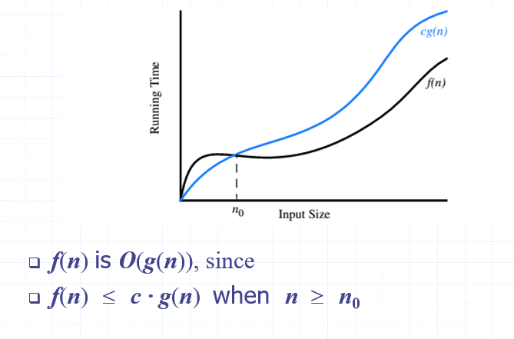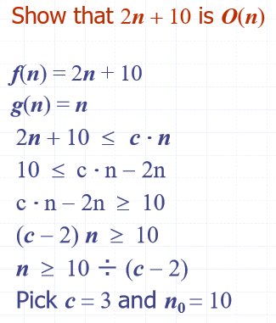

$f\left(n\right)$ is $O(g\left(n\right))$ means the growth rate of $f(n)$ is no more than the growth rate of $g(n)$. Big-O notation ranks functions according to their growth rate.

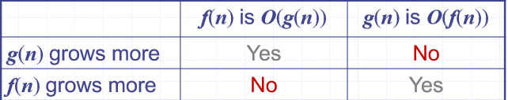

### Big-O Rules

1. If $f\left(n\right)$ is a polynomial of degree $d$, then $f(n)$ is $O(n^{d})$. We drop the lower order terms and the constants. If $f\left(n\right)= 3n^{2}+2n+4$, $f(n)$ is $O(n^{2})$.
2. $2n$ is technically $O(n^{2})$ as Big-O is just an upper bound however, we must use the **smallest possible** class of functions to give the tightest bound.
3. Use the simplest expression of the class, $3n+5$ is $O(n)$ instead of $O(3n)$

### Big- $Ω$ Notation

* Big-Omega notation describes a lower bound on a function.
* $f(n)$ is $Ω\left(g\left(n\right)\right)$ if $f(n)$ is asymptotically greater than or equal to $g(n)$
* That is, $f\left(n\right)$ is $Ω(g\left(n\right))$ fi there exists positive constants $c$ and $n_{0}$ such that $f\left(n\right)≥c∙g(n)$ for all $n≥n_{0}$

### Big- $θ$ Notation

* Big-Theta notation describes a tight bound on a function (if one exists)
* $f\left(n\right)$ is $Θ(g\left(n\right))$ if $f(n)$ is asymptotically equal to $g(n)$. That is, $f(n)$ is $Θ(g\left(n\right))$ if there exist positive constants $c_{1}$, $c_{2}$, and $n_{0}$ such that $c_{1}∙g\left(n\right)≤f\left(n\right)≤c_{2}$ for all $n≥n_{0}$.
* In other words, $f\left(n\right)$ is $Θ(n)$ if $O\left(n\right)=Ω(n)$

## Week 2

### Recursion

#### Linear Recursion

Steps:

1. Test for base cases, every possible chain of recursive calls must eventually reach a base case.
2. Perform a **single** recursive call.

#### Tail Recursion

* Recursive call as the last step
* Easily converted into iterative forms

#### Binary Recursion

* Two calls for each non-base case

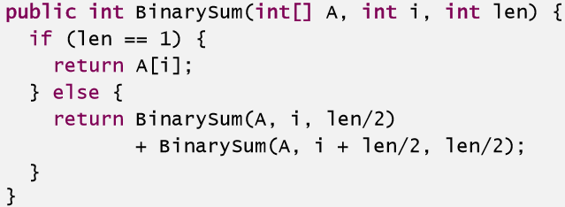

#### Multiple Recursion

* Multiple recursion, as the name suggests, makes potentially many recursive calls

### Selection Sort

* Base case: n = 1 as there is nothing to sort
* Recursive case: Scan each element of the array and find the largest element, swap it with the last element of the array and repeat this process on the first n-1 elements.

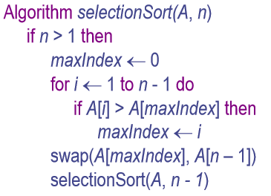

### Analysis of Recursive Algorithms

Using selection sort as an example:

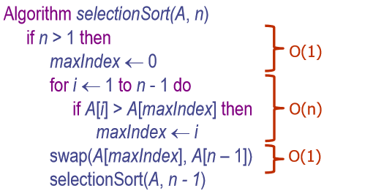

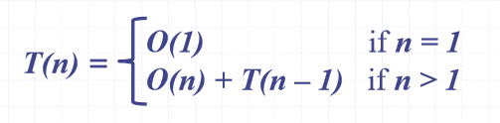

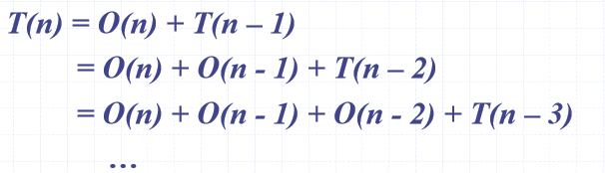

As n decreases by one each call, there will be n recursive calls in total:

Total calls = $T\left(n\right)=1+2+3+…+n-1+n=\frac{n\left(n+1\right)}{2}$ (using identity)

$T(n)$ is $O(n^{2})$

### Divide and Conquer Paradigm

Split the problem into smaller problems.

#### Binary Search

An example is binary search:

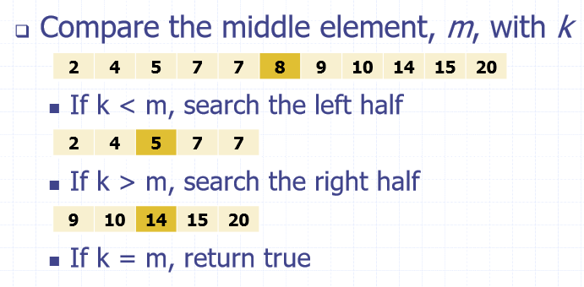

Pseudo Code:

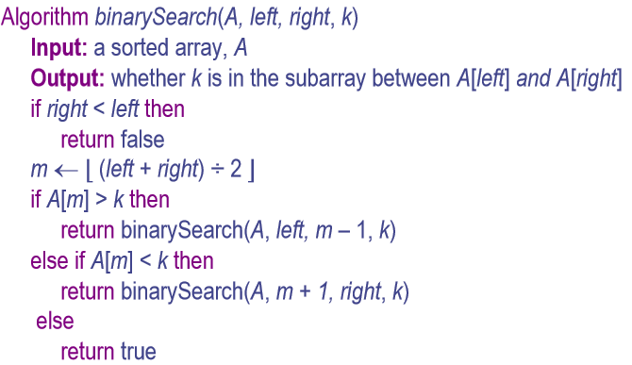

Analysis:

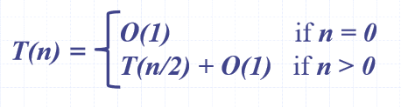

As n is halved on each recursive step, the run time can be described as $O(log n )$.

### Merge-Sort

* Sorting algorithm based on the device and conquer paradigm. Guaranteed $O\left(n log n \right)$ running time.
* Accesses data in a sequential manner, suitable for sorting data on a disk.

To sort input sequence A with n elements:

* Divide: partition A into two halves 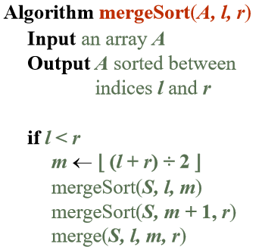
* Recur: recursively sort each half
* Conquer: merge the two halves

Merging two sorted sequences:

* Conquer step: Merging two sorted sequences, each with $n÷2$ elements, takes $O(n)$ time.

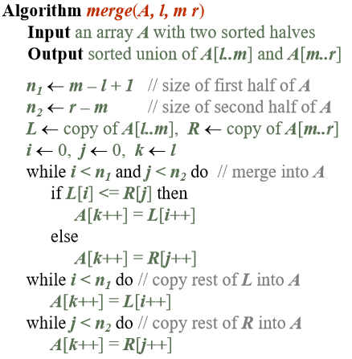 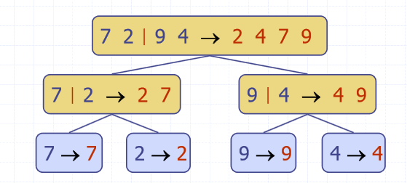

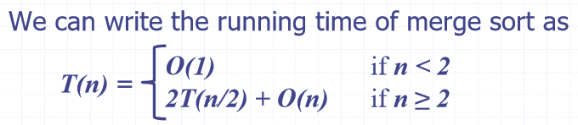

Analysis:

* Depth $h$ of the merge-sort tree is $O(loglog n)$
* Overall amount of work done at depth $i$ is $O(n)$
* Thus, the total running time of merge-sort is $O(nloglog n)$

### Quick-Sort

#### Overview

* Randomised divide-and-conquer sorting algorithm.
* Divide: pick a random element $x$ called the pivot and partition $S$ into
  + $L$, elements less than $x$
  + $E$, elements equal to $x$
  + $G$, elements greater than $x$
* Recur: Sort $L$ and $G$
* Conquer: join $L$, $E$ and $G$

#### Partition

* Partition the input sequence
  + Remove, in turn, each element $y$ from $S$
  + Insert $y$ into $L, E$ or $G$ depending on the result of the comparison with the pivot, $x$
* Each insertion and removal is at the beginning or end of a sequence and takes $O\left(1\right)$ time.
* Thus, the partition step takes $O(n)$ time.

#### Example

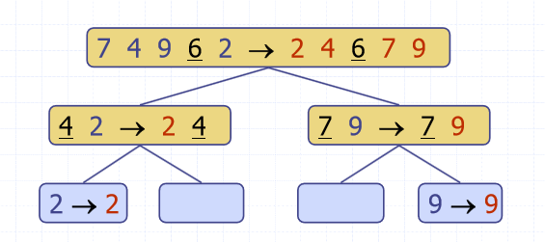

#### Running Time

Worst case:

* Worst case is when the pivot is the unique maximum or minimum element (rarely happens)
* Running time is proportional to the sum: $n+\left(n-1\right)+…+2+1$
* Thus, the worst case running time is $O(n^{2})$

Best case:

* Good pivot call: the sizes of $L$ and $G$ are each less than $3S÷4$
* Bad pivot call: one of $L$ and $G$ has a size greater than $3S÷4$

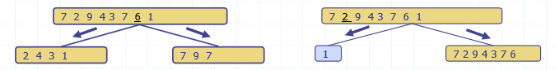

* Good calls have a probability of 0.5

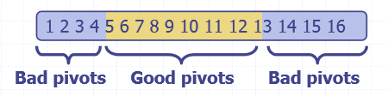

* The expected height of a quick-sort tree is $O(loglog n)$
* Amount of work done at nodes of the name depth is $O(n)$
* Thus, the expected running time is $O(nloglog n)$

#### In Place Implementation

Quick-Sort also has an in-place implementation (doesn’t use any extra space)

* In the partition step, use replace operations to rearrange the elements of the input sequence.
  + Elements less than the pivot have an index less than $h$
  + Elements equal to the pivot have an index between $h$ and $k$
  + Elements greater than the pivot have an index greater than $k$
* Recursive calls consider:
  + Elements with index less than $h$
  + Elements with index greater than $k$

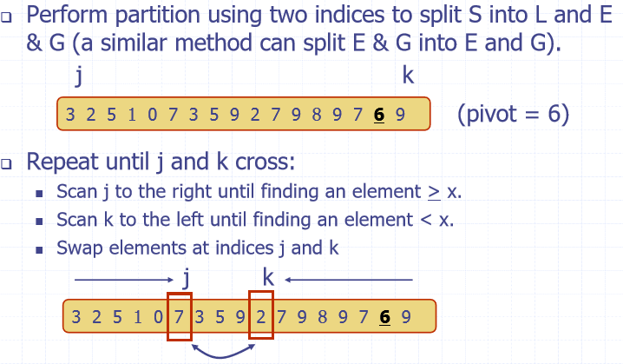

## Week 3

Any comparison-based sorting algorithm **MUST** run in $Ω(nloglog n)$ time

### Bucket Sort

#### Overview

* Let $S$ be a list of $n$ (key, element) items with keys in the range [0, N – 1]
* Bucket-sort uses the keys as indices into an auxiliary array B of lists (buckets)
  + Phase 1: Empty list S by moving each entry (k, o) into its bucket B[k]
  + Phase 2: For i = 0, …, N – 1, move the entries of bucket B[i] to the end of list S

#### Example:

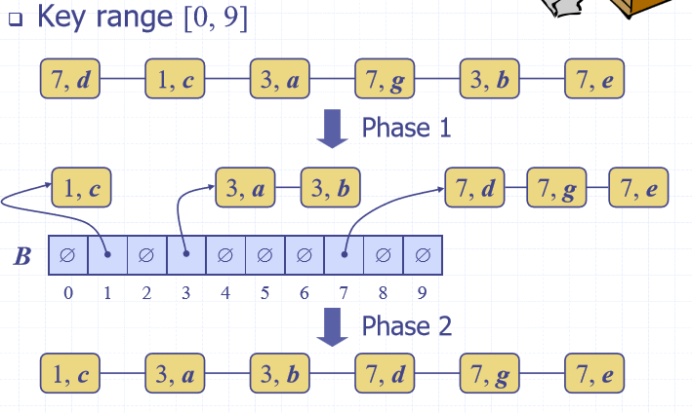

#### Pseudo Code:

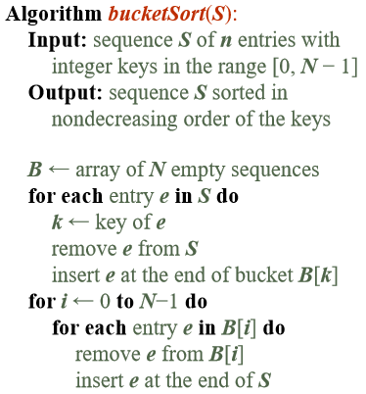 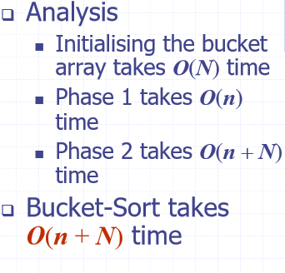

#### Properties

* Stable sort property
  + Relative order of any two items with the same key is preserved after the execution of the algorithm

### Radix Sort

#### Pseudo-Code

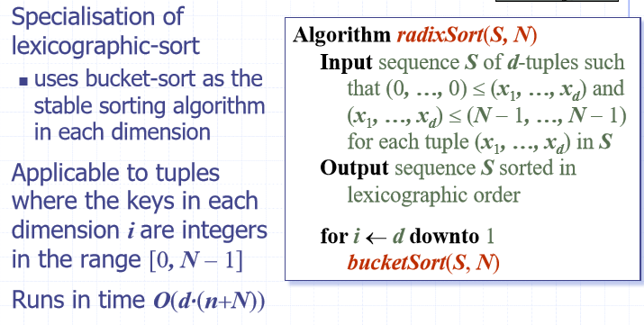

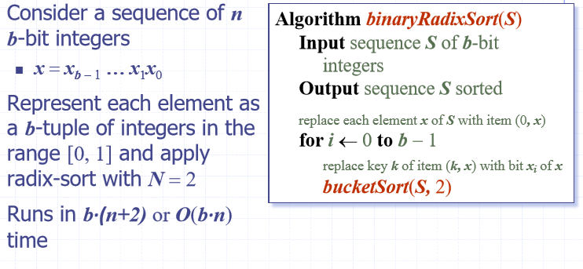

#### Example

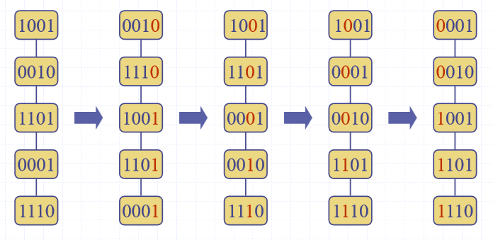

#### Memory Usage

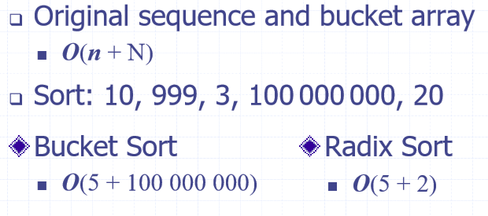

The “2” in radix sort comes from the two digits of a binary number, 0 and 1.

### Linear Data Structure

* A linear structure is one whose elements can be seen as being in a line or sequence. That is, one element follows the next.
  + Lists
  + Stacks
  + Queues
  + Vectors
  + Sequences

#### Array Implementation Efficiency

* Accessing an element:
  + O(1)
* Iterating over elements
  + O(n)
* Inset/Delete of elements
  + O(n) – must find element, then have to make new array without deleted element. For insertion, must create new array with +1 space and insert.
* Memory usage
  + O(n)

#### Singly Linked List

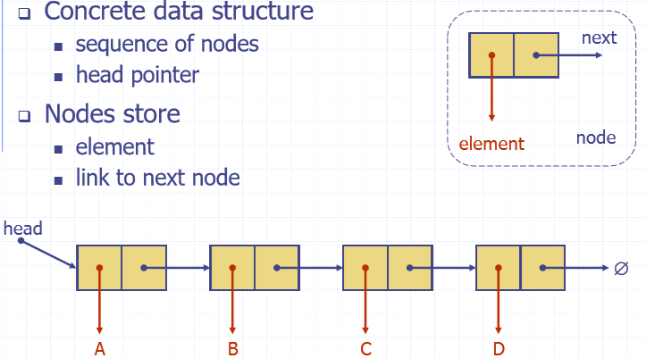

#### Doubly Linked List

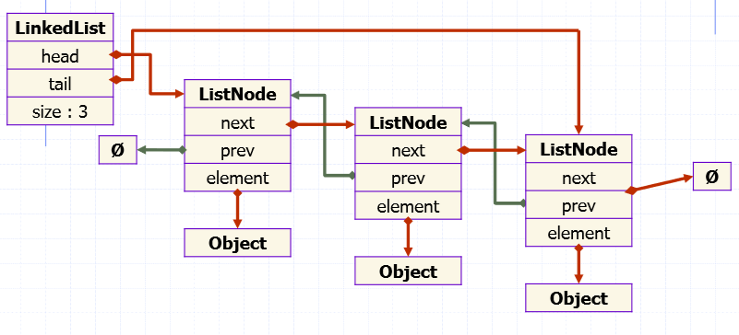

* Each node stores a pointer to previous and next.

#### Circularly Linked List

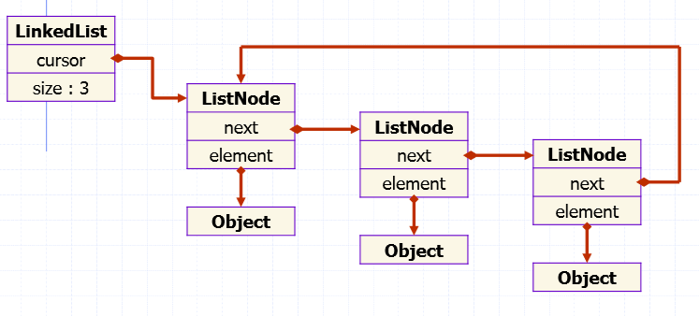

#### Linked List Implementation Efficiency

* Accessing head
  + O(1)
* Iterating over elements
  + O(n)
* Memory usage
  + O(n)
* Insertion/Deleting
  + O(n) – need to iterate to find element/space to delete/insert and change links.

### Stacks

* Stores arbitrary objects
* Insertion and deletion are last-in, first-out (LIFO). Insertion and removal is done from the top of the stack.

#### Operations

* push(T)
* T pop()
* T top()
* Integer size()
* Boolean isEmpty()

#### Array Based Stack

* Add elements from left to right
* Variable keeps track of index of top element
* Space complexity is O(N), N is the fixed array size
* Each operation takes O(1) as we already know the index.

### Queues

* Insertion and deletions are first in, first out (FIFO).
* Exact same as a waiting line (queue). Insertions at rear of queue, removals at front.

#### Operations

* Enqueue(T)
* T dequeue()
* T first()
* Integer size()
* Boolean isEmpty()

#### Array Based Implementation

* Use an array of size N in circular fashion.
* Two variables keep track of the front and the size

## Week 4

### Array List

#### Operations

Insertion:

* Add(i, o), worst case is when the index is equal to 0 as the entire array has to be expanded. Takes O(n) time.

Removal:

* Remove(i), fill the hole left by the removed element. Takes O(n) time.

### Amortised Time

If an operation only happens every so often, can use amortised time. An example is doubling an array when its full when doing a push. Most of the time, push takes O(1) as we know the index of the final element. However, when the array is full, can double the size of it to make more room which is an O(n) operation. But since most of the time it is O(1), we can use amortised time. Amortised time is T(n)/n so for a push operation, O(n)/n which is O(1).

### Positional Lists

Methods:

* First()
* Last()
* Before(p)
* After(p)
* isEmpty()
* size()
* addFirst(e)
* addLast(e)
* addBefore(p, e)
* addAfter(p, e)
* set(p, e)
* remove(p)

Can be implemented using a doubly linked list due to after() and addLast() methods.

### Iterators

Iterable interface has the following method:

* iterator()

Each call to iterator() returns a new interator() instance. Can define custom iterator for any data type. Even custom data types.

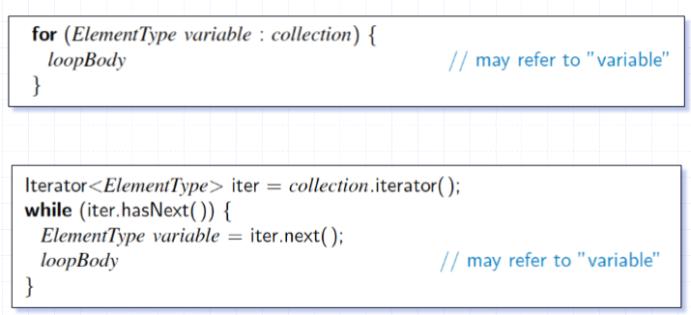

### Tree Basics

* Abstract model of a hierarchical structure.

#### Terminology

* Root – the topmost node
* Internal node – any node with a child
* External node (leaf) – any node without a child
* Edge – the line connecting two nodes
* Ancestors of a node – parents
* Descendant of a node – the children
* Siblings – nodes on the same level
* Degree – how many direct children it has
* Level – the level starts at the root node and is 0, each step down, add one to the level.
* Depth – number of descendants from the root
* Height – number of ancestors from the lead – like level but starts at the leaf nodes and increases upwards.
* Subtree – tree consisting of a node and its descendants
* K-ary tree – each internal node has at most, k children.

#### Tree ADT

General methods:

* Size()
* isEmpty()
* iterator()
* positions()
* root()
* parent(p)
* children(p)
* numChildren(p)
* inInternal(p)
* isExternal(p)
* isRoot(p)
* replace(p, o)
* addRoot(o)
* remove(p)

### Tree Traversals

Draw the Euler path, the outline of the tree.

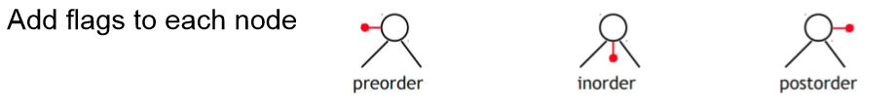

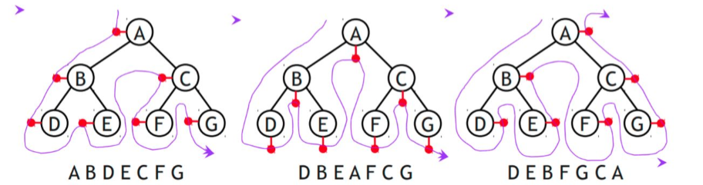

### Binary Tree

* Each internal node has at most two children
  + Exactly two for proper binary trees

#### Terminology

* Level l is full if it contains 2l nodes
* A complete binary tree, for height h is if levels 0 to h-1 are full and in level h, all leaf nodes are as fare left as possible
* A proper binary tree is when every node, except for leaves, has two children. Also called a full binary tree.

#### Properties of Complete Binary Trees

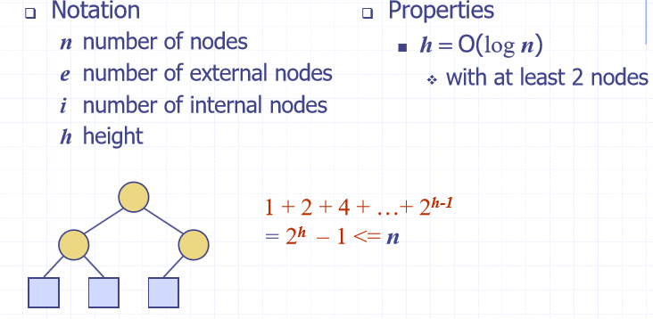

#### Properties of Proper Binary Trees

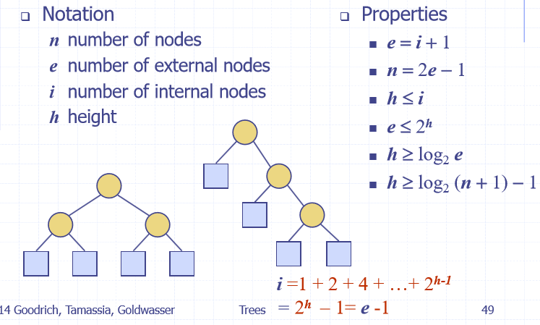

#### Binary Tree ADT

* All methods from tree ADT as well as:
* Left(p)
* Right(p)
* Sibling(p)

#### Linked Structure Implementation

Node stores:

* Element
* Parent node
* Left child node
* Right child node

#### Array Based Implementation

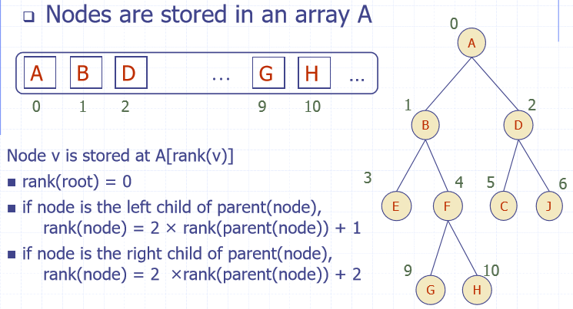

#### Breadth First Traversal

Visit all nodes at depth d before visiting nodes at depth d+1

## Week 5

### Priority Queue

* Each entry is a key, value pair
* Methods:
  + Insert(k, v)
  + removeMin()
  + min()
  + size()
  + isEmpty()

#### Queue VS Priority Queue

* Queue
  + FIFO
  + Elements are added at end of queue
* Priority Queue
  + Elements are stored as entries
  + Entry with highest priority (lowest key) is removed first

#### Implementation with an Unsorted List

Insert is O(1)

removeMin and min take O(n)

#### Implementation with a Sorted List

Insert is O(n)

removeMin and min take O(1)

### Heaps

Binary tree storing keys at its nodes and satisfying the following properties:

* Heap-order: for every internal node v other than the root, key(v) $≥$ key(parent(v)). The key of the child is always greater or equal to its parent’s key.
* Complete binary tree

#### Height of a Heap

* A heap storing n keys has a height of O(log(n))

#### Heaps and Priority Queues

A heap can implement a priority queue. Store a (key, element) at each node.

Traversal takes O(log(n))

Insertion algorithm:

1. Find the new insertion node, z. The new last node
2. Store key at z
3. Restore the heap-order property by doing an up-heap

Remove Min algorithm:

1. Replace the root key with the key of the last node, w
2. Remove w
3. Restore the heap-order using down heap

#### Upheap

* After inserting a new key, k, the heap-order property may be violated. Since a heap has height O(log(n)), upheap runs in O(log(n)) time.
* Upheap swaps k along an upward path from the insertion node until k reaches the root or a node whose parent has a key less than or equal to k.

#### Down Heap

* Runs in O(log(n)) time as well
* If a node has no right child, choose the left child.
* If a node has both children, choose the one with the smallest key.
* Down heap replaces root key with key w of the last node and swaps w along a downwards path from the root.

#### Array Based Heap Implementation

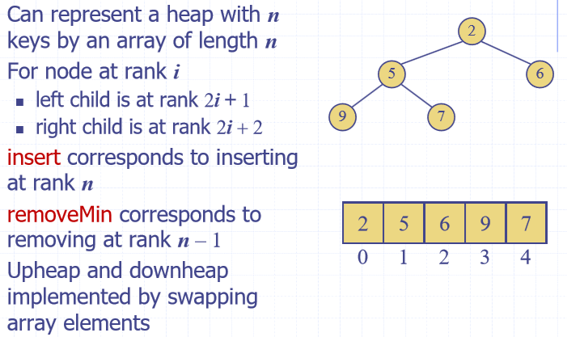

#### Heapsort

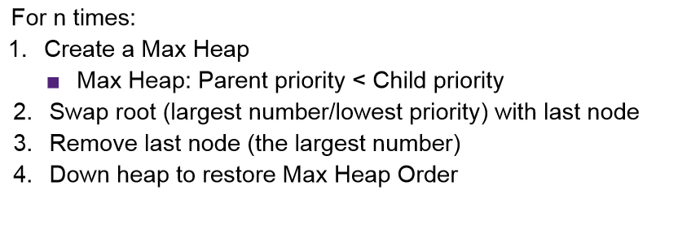

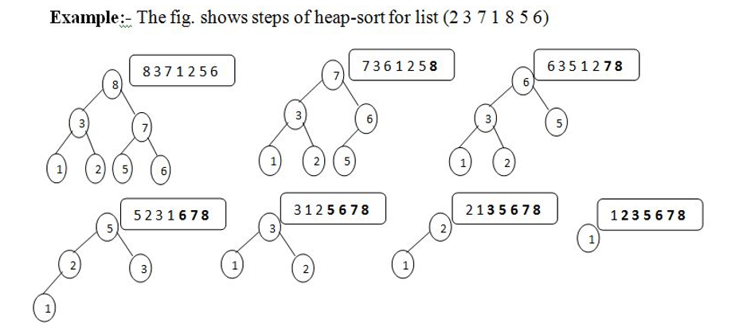

#### Top-Down Heap Construction

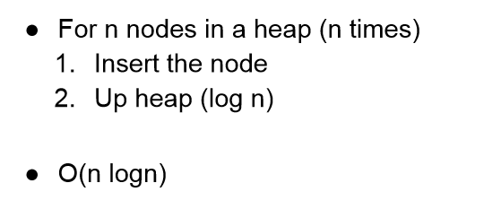

#### Merge Two Heaps

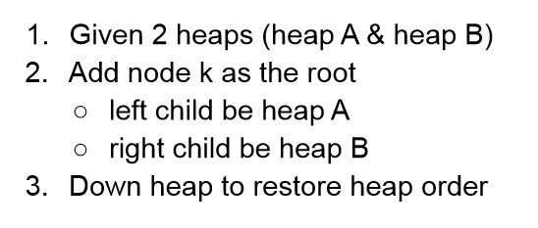

#### Bottom-Up Heap Construction

* Takes O(n) time

Create a heap containing 16, 15, 4, 12, 25, 5, 7:

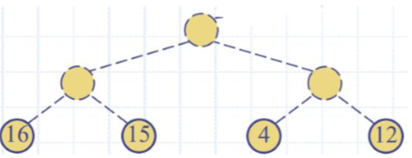 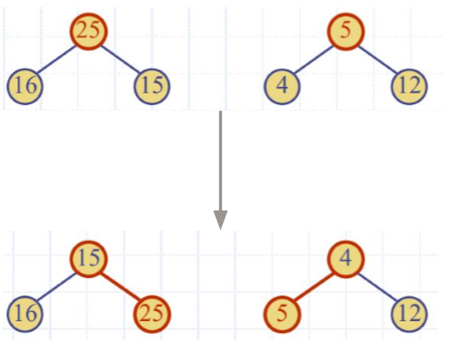

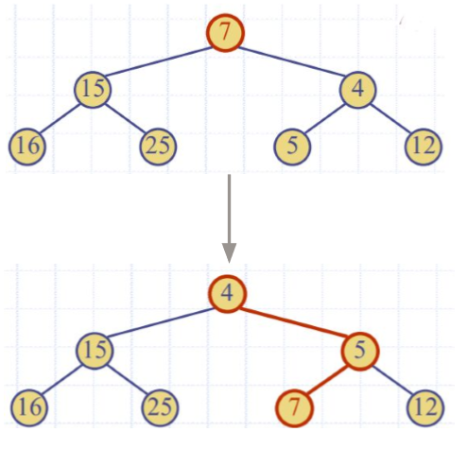

## Week 6

### Hash Tables

* Array of size N with n elements
* Keys are integers from 0 to N
* Store the value at index k

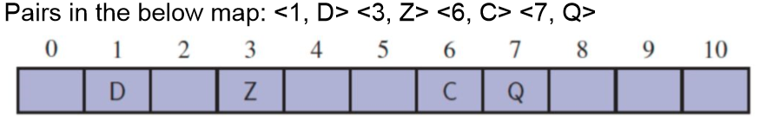

#### Hash Codes

* When keys are not integers that can be easily indexed
* Convert key to index in array

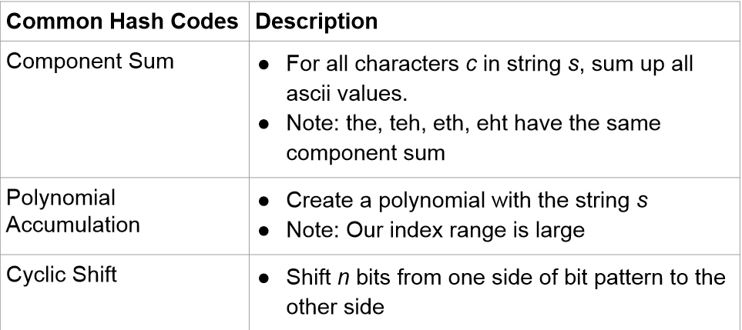

#### Compression Functions

* Hash codes may be in a large range, for example could have a range of 100000
* Reduce the number of potential hash codes

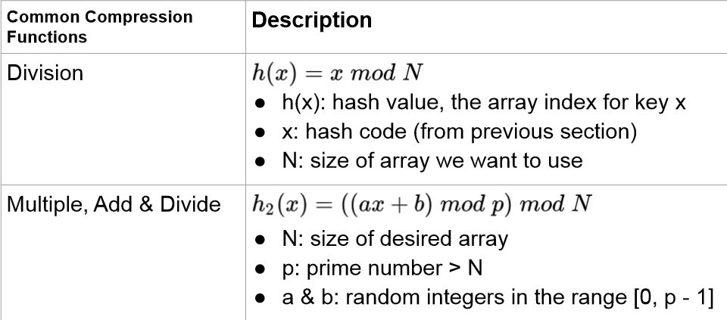

#### Collision Handling

* Due to compression, we may give the same hash code to multiple keys.
* Common collision handling methods:
  + Separate chaining – each cell in the table points to linked list of entries that map there
  + Linear probing – Places colliding items in next available cell. Each table cell is inspected by probing.
  + Quadratic probing – Probe using a quadratic index
  + Double hashing – use 2 hash codes
* Hashing:
  + Worst case: O(n) – many collisions
  + Expected case: O(1) – no collisions

#### Load Factor

* How full the table is
$load factor\left(a\right)=\frac{n}{N}$

* A good load factor is 85%
* Expected number of probes:

$\frac{1}{1-α}$

### Binary Search Trees

* Internal nodes satisfy the following property:
  + Let u be the left subtree, v the parent and w the right subtree:
    - Key(u) $≤$ key(v) $≤$ key(w)
* External nodes don’t store items

#### Searching in a BST

To find key k:

1. Trace from root node down the tree
2. If less then node, go to left subtree, if greater than node, go to right subtree
3. If you find the node, return. If you hit a leaf node, k is not in the tree

To find 4:

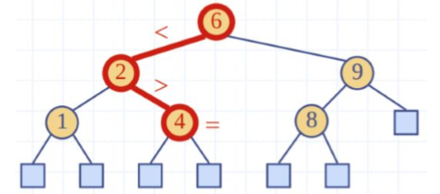

#### Inserting into a BST

* Assume k is not in BST

1. Trace down the tree until a leaf node is found
2. Insert k into the tree at that leaf node
3. Expand the tree so the node is now an internal node

#### Deletion from a BST

* Assume k is in the BST

1. Trace down to find key k
2. Remove node and replace it with the next node, v from the in-order traversal
3. Reconnect the tree

#### Performance

Finding, inserting, and deleting:

* Best case: O(log(n))
* Worst case: O(n)

## Week 7

### AVL Trees

* Balanced binary search tree
* Balanced means that for every internal node, the height difference between the left and right subtree is at most one.

#### Insertion

1. Insert node like in a binary search tree
2. Preform tri-node restructuring

#### Tri-Node Restructuring

* Restores the balance in the tree

Steps:

1. Select the first unbalanced node x such that the difference between the height of its left and right branch is unbalanced. This is the first ancestor which is unbalanced
2. Select the child of x with higher height
3. Select the child of that child with higher height
4. Restructure so that these three nodes are balanced, maintaining in-order
5. Subtrees may need to be re-arranged, but should stay in-order.

#### Deletion

1. Remove from tree as if it’s a BST
2. From the deleted node, move up to the first unbalanced node
3. Tri-node restructuring to restore height property

#### Performance with a Linked Binary Tree

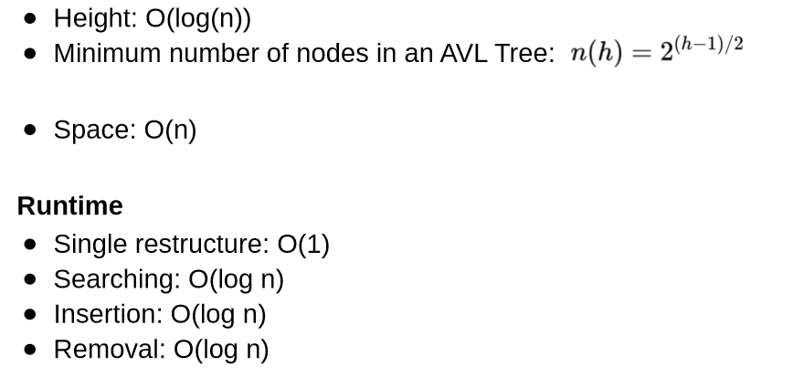

### Splay Trees

* Nearly balanced BST
  + No rules on height, that is, h is O(n)
* Faster to access most recently used trees
* All operations involve a “splay” action

#### Finding a Node

1. Find a node like a BST
2. Splay the node up to the root, even if you didn’t find the node, splay up the node last accessed

#### Splaying

* Moves the most recently accessed/inserted node to the root

1. Select the node x we want to splay from
2. Select parent of x
3. If it exists, select parent of that parent (grandparent of x)
4. Restructure so x Is the highest of the selected 2 or 3 nodes while maintaining in-order
5. Subtrees may need to be rearranged, buy should also stay in-order
6. Repeat from step 1 until x is the root

* Zig-Zig is a double right rotation
* Zag-Zag is a double left rotation
* Zig-Zag is a right-left rotation
* Zag-Zig is a left-right rotation

#### Insertion

1. Insert a node like a BST
2. Splay the inserted node up to the root

#### Removal

1. Remove a node like a BST
2. Splay up to the root
   1. If the node is not found, splay the node that ended the search
   2. If the node is found, splay the parent of the removed node

* Balanced search tree
* Nodes can have:
  + 1 key, 2 children
  + 2 keys, 3 children
  + 3 keys, 4 children
* Leaf nodes are on the same level

#### Finding in a 2-4 Tree

Start at the root:

1. Check if the number is in the node
2. If not in the node, go to the child between the 2 numbers in the node
3. Repeat until the number is found or a leaf node is reached

#### Insertion

1. Find the location to insert in a 2-4 tree
2. If node overflows, reorder

Example, inserting 39:

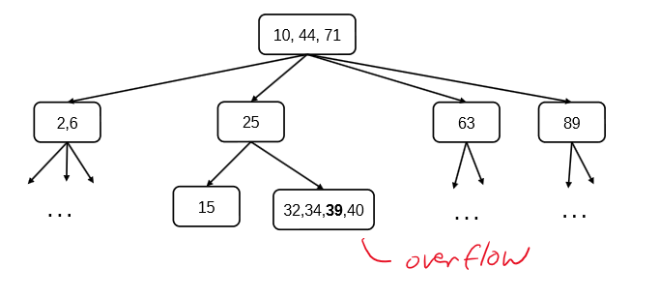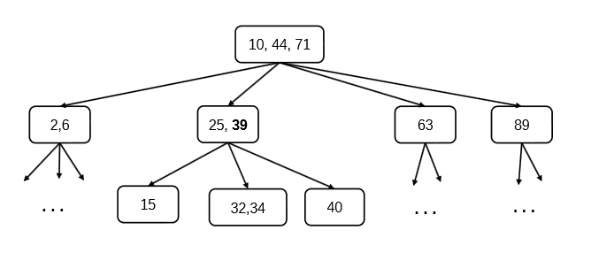

#### Removal

* Delete as in BST, replace with in-order successor if it has children
* If 1 node remains (underflow):
  + If sibling is 3- or 4-node, transfer
  + If sibling is 2-node, fusion

### Red Black Trees

* BST
* A node is either red or black
* Root and leaves (nulls) are always black
* If a node is red, its children are black
* All paths from node to leaves have the same number of black nodes

#### Underflow

To handle underflow at node v, with parent u consider two cases:

1. Adjacent sibling of v are 2-nodes – Fusion operation: merge v with an adjacent sibling, w and move an entry from u to the merged node, v’
2. Adjacent sibling w of v is a 3-node or a 4-node – Transfer operation: 1. Move a child of w to v. 2. Move an item from u to v. 3. Move an item from w to u

#### Overflow

To handle overflow at a 5-node, v, with a split operation:

* Let v1…v5 be the children of v and k1…k4 be the keys of v. Node v is replaced by nodes v’ and v’’. V’ is a 3-node with keys k1 and k2 and children, v1, v2 and v3. V’’ is a 2-node with key k4 and children v4 and v5. K3 is inserted into the parent of u and v (a new root may be created)
* Overflow may propagate to the parent node u

#### Insertion

1. Insert node x like a BST as a red node
2. Recolour and rotate nodes to fix violations

3 Scenarios

1. Node x is the root
2. X’s uncle is red (uncle is when the parent has the same grandparent as another node on the same level)
3. X’s uncle is black (line)

##### Case 1: X is the root:

Solution: Colour x black

##### Case 2: X’s uncle is red:

Solution: Recolour x’s parent, grandparent, and uncle

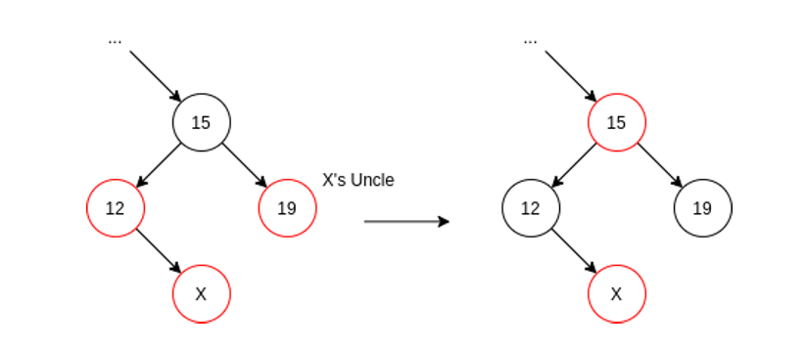

##### Case 3: X’s uncle is black:

Solution: Perform a tri-node reconstruction on X, X’s parent and grandparent (put the second node in the in-order traversal as a parent)

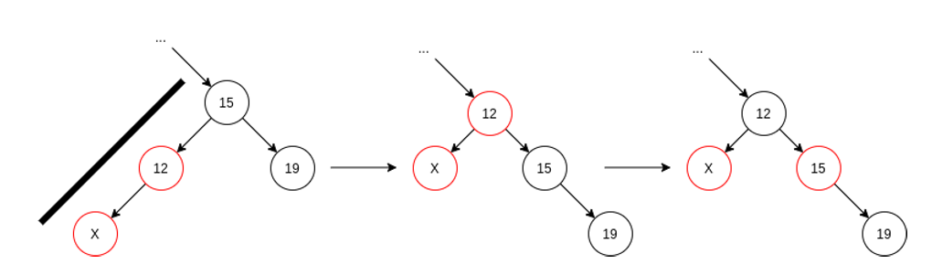

#### Deletion

1. Remove the same as a BST
2. Recolour and rotate to fix violations

Takes O(log(n)) time.

Let q be the internal node removed, r the external node removed and p the sibling of r.

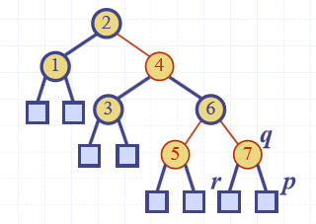

* If q was red, we are done
* If q was black, either both children were external, or q had one red child, p, recolour p to be black.

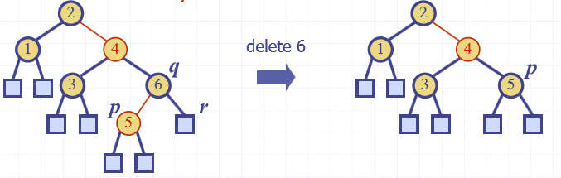

* If q was black, with two external nodes, colour p double black which corresponds to an underflow

#### Remedying a Double Black

Double black node is p with sibling y, three cases:

1. Y is black and has a red child, x – Perform a restructuring, equivalent to a transfer, and we are done
2. Y is black, and its children are both black – perform a recolouring, equivalent to a fusion
3. Y is red, perform an adjustment, after which, either case 1 or case 2 applies

#### Comparison to AVL Trees

* Maintain tighter restrictions on balance than red-black trees
* AVL trees have better search performance, but more expensive insert/delete
* Search, insert and remove is O(log(n))

### (a, b) Trees

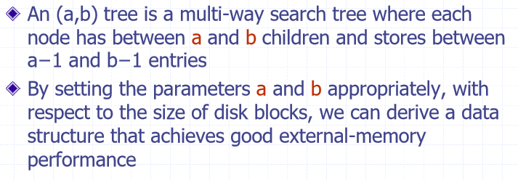

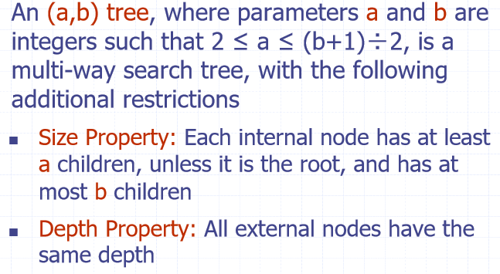

#### Height

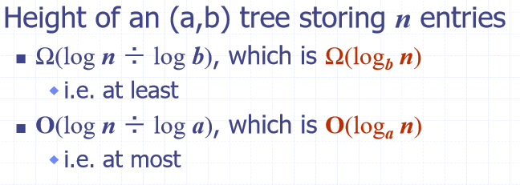

#### Search and Updates

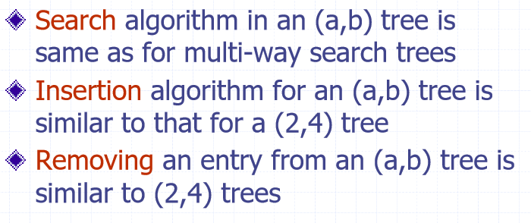

### B-Trees

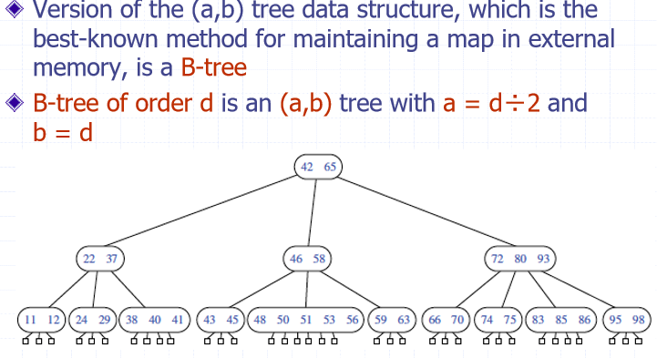

## Week 8

### Graphs

A graph is a pair (V, E), where:

* V is a set of nodes, called vertices
* E is a collection of pairs of vertices, called edges
* Both vertices and edges can be thought of as positions and may store elements.

#### Edge Types

* Undirected edge
  + Unordered pair of vertices (u, v)
  + An example is a flight route
* Undirected graph
  + All the edges are undirected
  + An example is a flight route network
* Directed edge
  + Ordered pair of vertices (u, v)
  + First vertex, u, is the origin
  + Second vertex, v, is the destination
  + An example is a flight
* Directed graph
  + All the edges are directed
  + An example is a flight network

#### Terminology

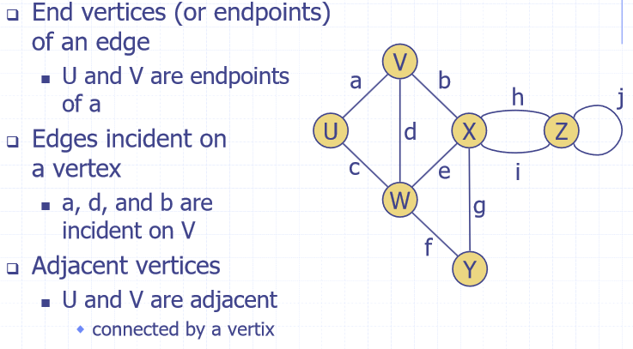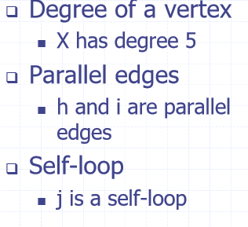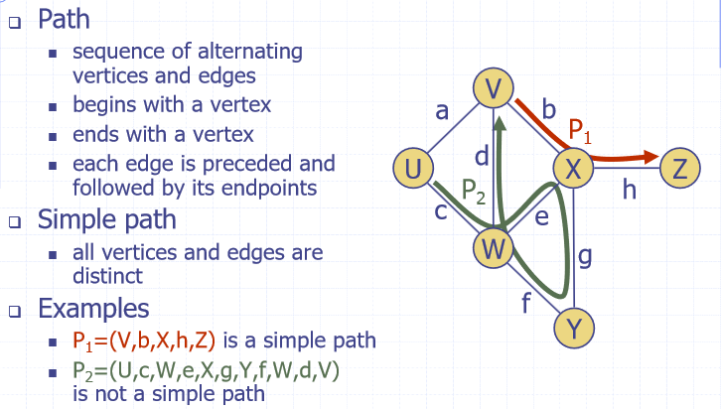

$P_{2}$ isn’t simple as W is passed twice.

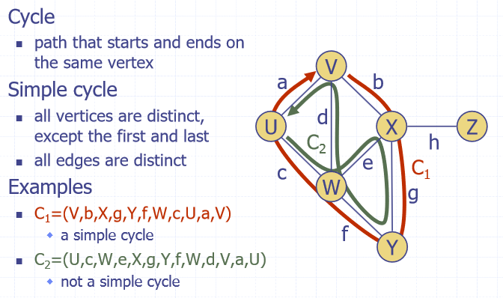

$C_{2}$ is not a simple cycle as W is touched twice.

#### Subgraphs

* Subgraph S of a graph G is a graph such that:
  + Vertices of S are a subset of the vertices of G
  + Edges of S are a subset of the edges of G
* Spanning subgraph of G is a subgraph that contains all the vertices of G, doesn’t have to be all the edges.

#### Connectivity

* Graph is connected if there is a simple path between every pair of vertices
* Connected component of graph G is a connected subgraph of G

#### Trees and Forests

* Undirected graph T is an unrooted tree if:
  + T is connected
  + T has no simple cycles
* An undirected graph is a forest if it contains no simple cycles. Doesn’t have to be connected.
* Spanning tree of a connected graph is a spanning subgraph that is a tree.
* Spanning forest of a graph is a spanning subgraph that is a forest.

#### Graph Density

Let n be number of vertices and m be the number of edges.

Undirected simple graph: $D=\frac{2m}{n\left(n-1\right)}$

Directed simple graph:

$D=\frac{m}{n\left(n-1\right)}$

Sparse:

$m≈O(n)$

Dense:

$m≈O(n^{2})$

#### Graph ADT

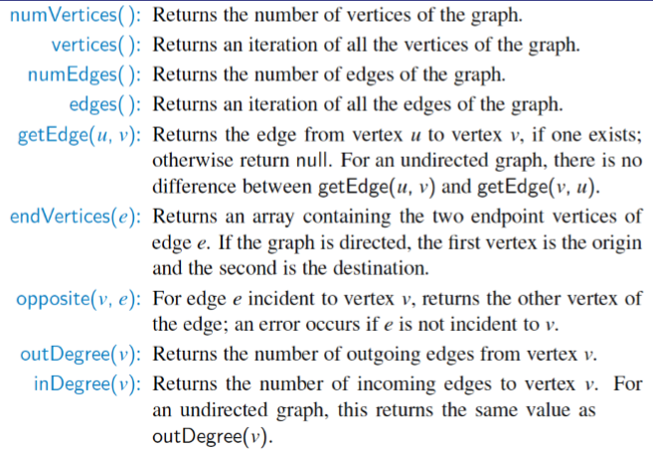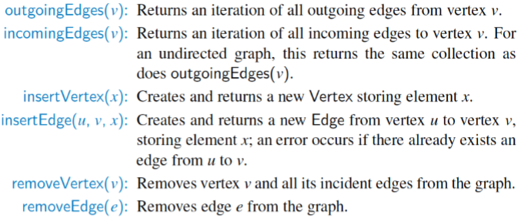

#### Edge List

* Sequence of edges, represented by vertex pairs.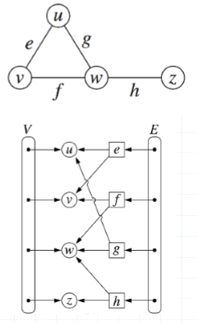
* Structure
  + Vertex object
    - Element
    - Reference to position in vertex sequence
  + Edge object
    - Element
    - Origin vertex object
    - Destination vertex object
    - Reference to position in edge sequence
  + Vertex sequence
    - Sequence of vertex objects
  + Edge sequence
    - Sequence of edge objects

#### Adjacency List Structure

* Extends edge list
* Incidence sequence for each vertex
  + Sequence refers to edge objects of incident edges
* Augmented edge objects
  + References to associated positions in incidence sequences of end vertices.

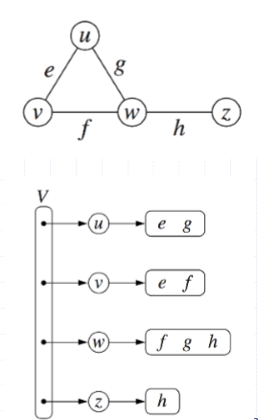

* Adapts adjacency list
* Incidence list becomes a map

#### Adjacency Matrix Structure

* Edge list structure
* Augmented vertex objects
  + Integer key (index) associated with vertex
* 2D-array adjacency matric
  + Reference to edge objects for adjacent vertices
  + Null for nonadjacent vertices
* “Old fashioned” version
  + 0 for no edge
  + 1 for edge

#### Performance of Different Structures

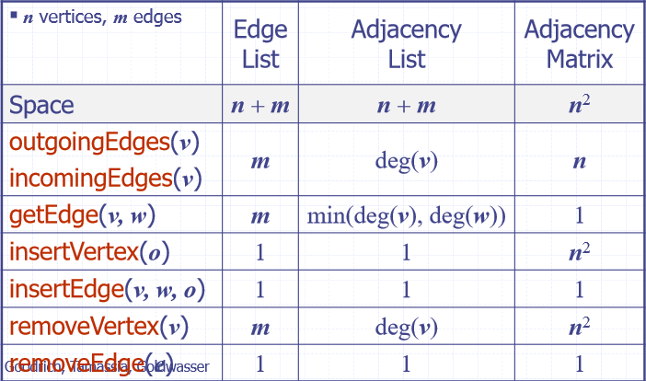

### Depth First Search (DFS)

* General technique for traversing a graph
* Runs in O(n + m)
* Visits all the vertices and edges of G
* Determines whether G is connected
* Computes the connected components of G
* Computes a spanning forest of G

#### Pseudo-Code

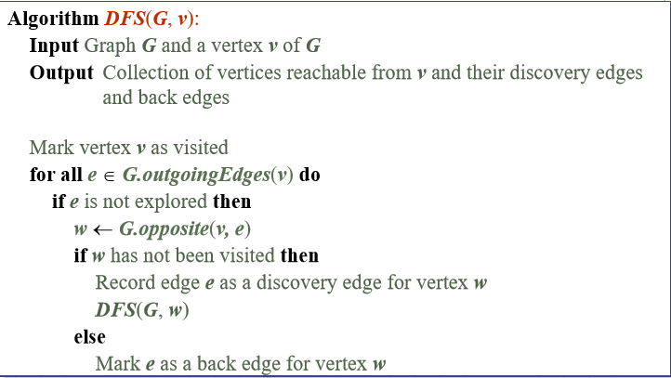

#### Properties

1. DFS(G, v) visits all the vertices and edges in the connected component of v
2. Discovery edges labelled by DFS(G, v) form a spanning tree of connected component of v

#### Analysis

* Setting/getting a vertex/edge label takes O(1) time
* Each vertex is labelled twice, once as unexplored, once as visited
* Each edge is labelled twice, one as unexplored, once as discovery or back
* Method for outgoingEdges is called once for each vertex
* DFS runs in O(n + m) time, provided the graph is implemented as an adjacency list

### Breadth-First Search

* General technique for traversing a graph
* BFS traversal of a graph G:
  + Visits all vertices and edges of G
  + Determines whether G is connected
  + Computes the connected components of G
  + Computes a spanning forest of G

#### Pseudo-Code

From a vertex:

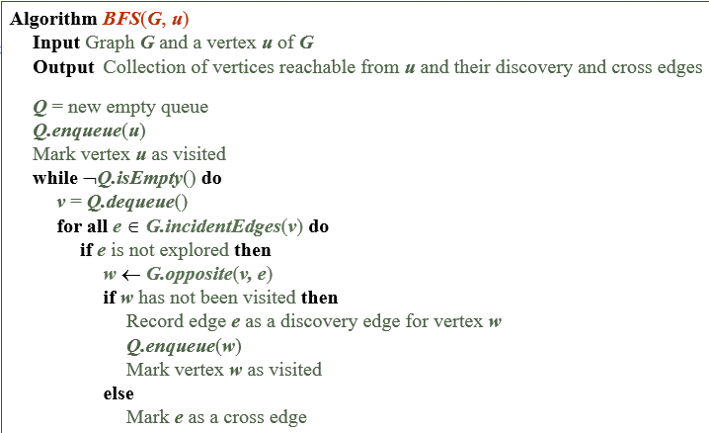

For an entire graph:

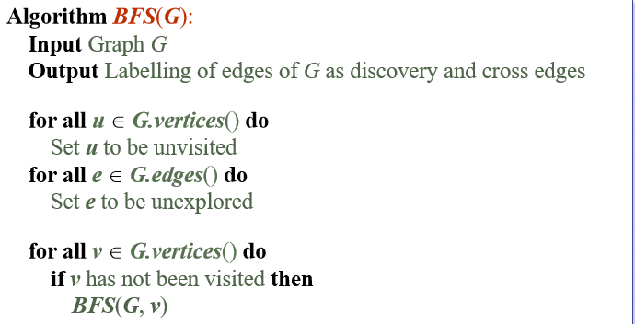

#### DFS vs BFS

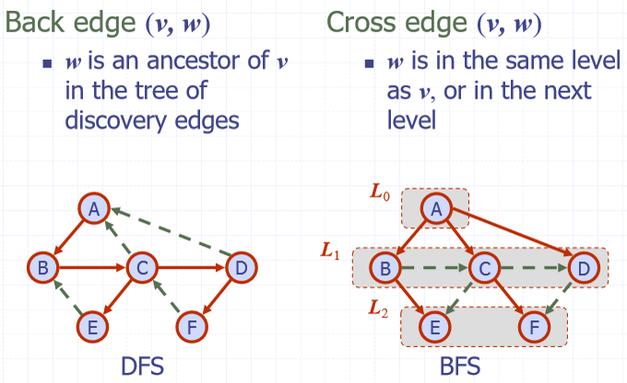

BFS can find the minimum number of edges between 2 vertices, DFS can’t.

#### Properties

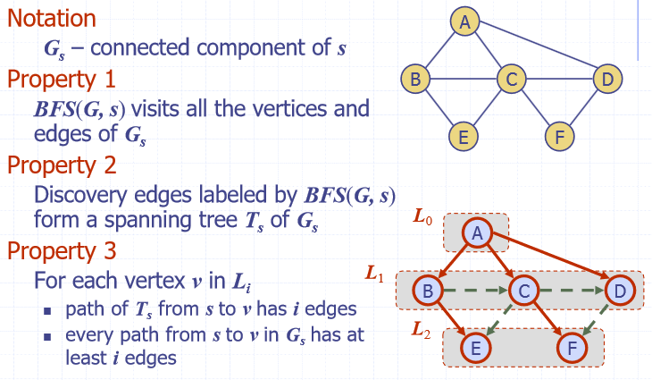

#### Analysis

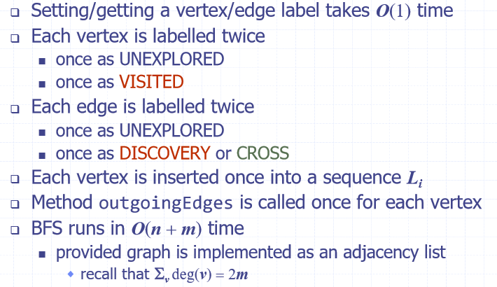

### Directed Graphs

* Graph whose edges are all directed
* Applications
  + One-way streets
  + Flights
  + Task scheduling

#### Properties

* Graph G=(V, E) such that:
  + Each edge goes in one direction
    - Edge (a, b) does from a to b but not b to a
* If G is simple
$m≤n∙(n-1)$

* If in-edges and out-edges are kept in separate adjacency lists, can perform listing of incoming edges and outgoing edges in time proportional to their size.

#### Directed Graph Traversal

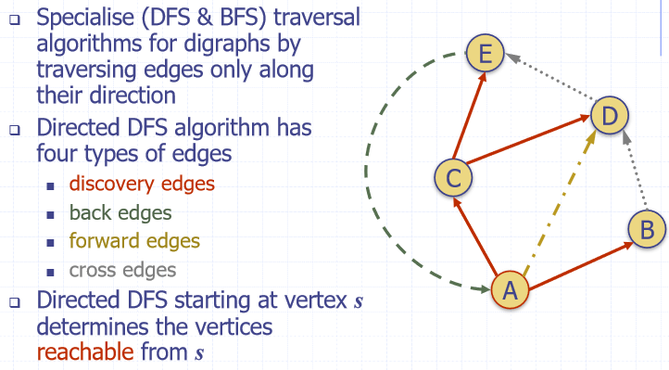

#### Reachability

* DFS tree rooted at v, vertices reachable from v via directed paths

#### Strong Connectivity

* Each vertex and reach all other vertices
* Algorithm:
  + Pick a vertex v in G
  + Perform a DFS from v in G
    - If there’s a w not visited, false
  + Let G’ be G with edges reversed
  + Perform a DFS from v in G’
    - If there’s a w not visited, false. Otherwise, true
  + Running time: O(m + m)

#### DAG’s and Topological Sorting

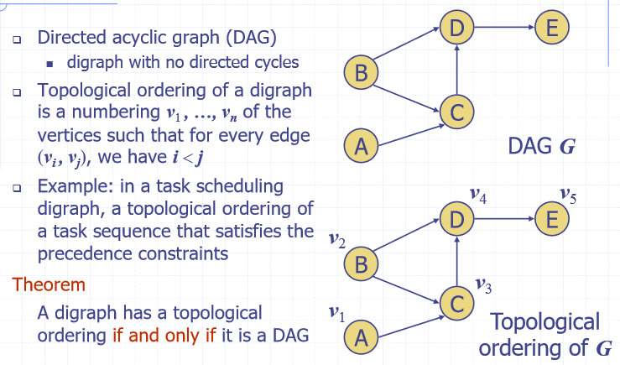

Algorithm:

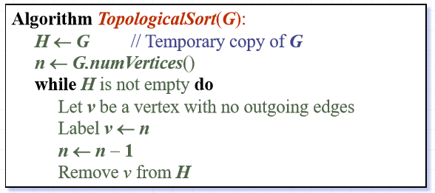

Running time is O(n + m)

## Week 9

### Weighted Graph

* Each edge is given a numerical value called the weight of the edge

#### Shortest Path

* Given a weighted graph and two vertices, u and v, find a path of minimum total weight between u and v. Length of the path is the sum of its edges.
* Property 1:
  + Sub-path of a shortest path is itself, a shortest path
* Property 2:
  + There is a tree of shortest paths from a start vertex to all other vertices

### Dijkstra’s Algorithm

* Computes the distances of all the vertices from a given start vertex, s
* Called a greedy algorithm
* Assumptions:
  + Graph is connected
  + Edges are undirected
  + Edge weights are not negative
* Grows a “cloud” of vertices, beginning with s and eventually covering all the vertices
* Store a label, d(v) at each vertex representing the distance of v from s.
* At each step:
  + Add to the cloud the vertex u outside the cloud with the smallest distance label d(u)
  + Update the labels of the vertices adjacent to u.
* Edge relaxation
  + Consider an edge e = (u, z) where:
    - U is the vertex most recently added to the cloud
    - Z is not in the cloud
  + Relaxation of edge e updates distance d(z)

$d\left(z\right)=min⁡\{d\left(z\right), d\left(u\right)+weight\left(e\right)\}$

Example of edge relaxation:

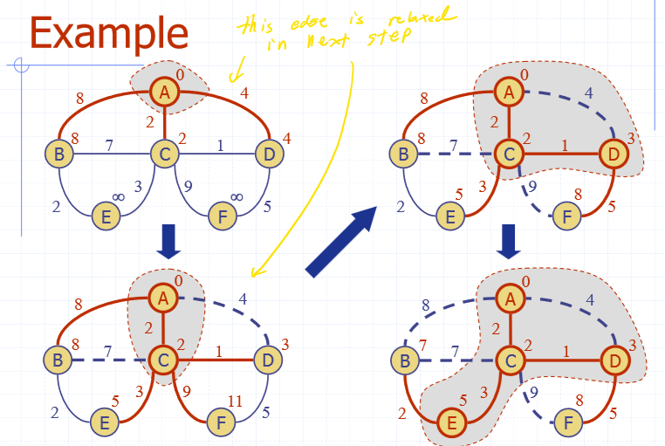

#### Pseudo-Code

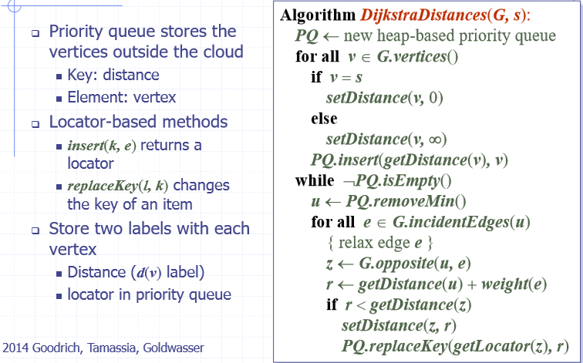

#### Analysis

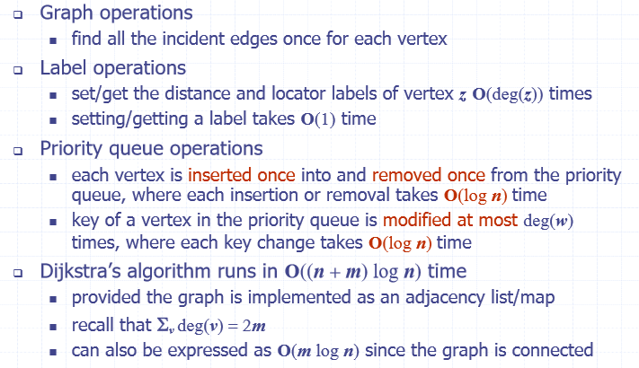

### Minimum Spanning Trees

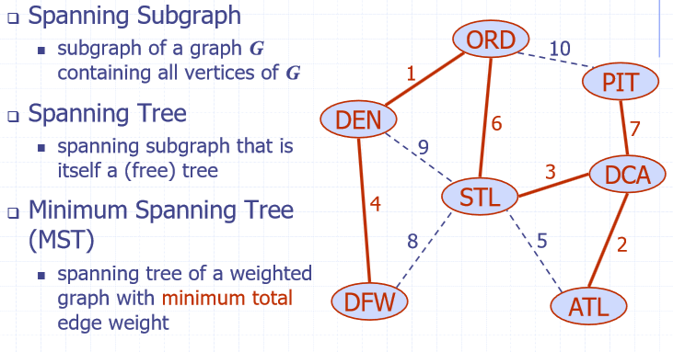

#### Cycle Property

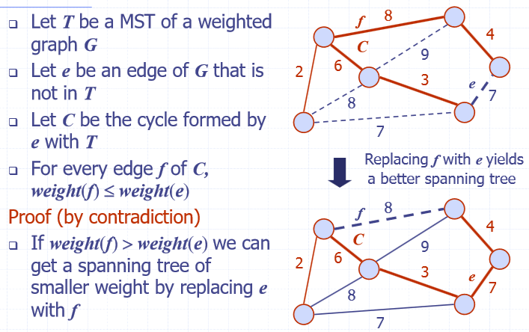

#### Partition Property

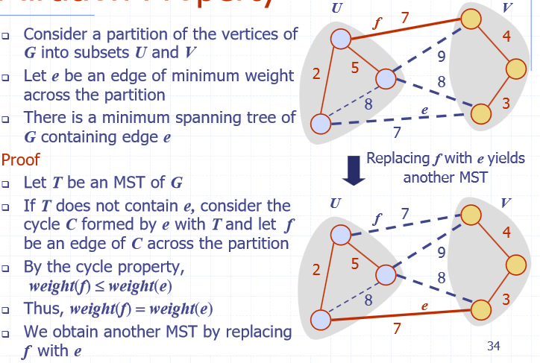

#### Prim-Jarnik’s Algorithm

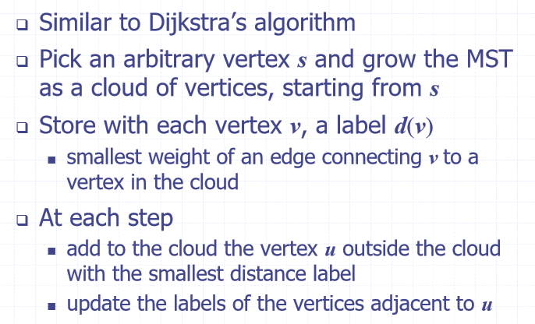

#### Pseudo-Code

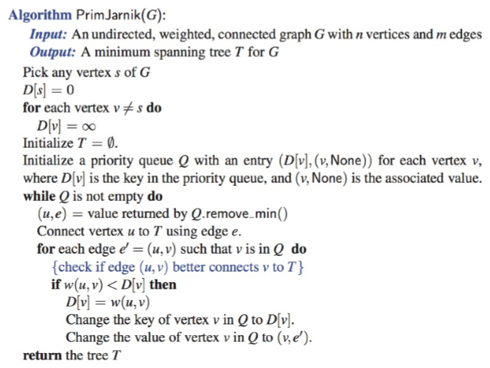

#### Analysis

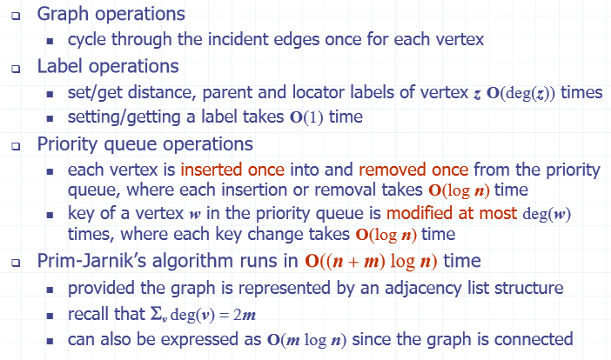

### Kruskal’s Algorithm

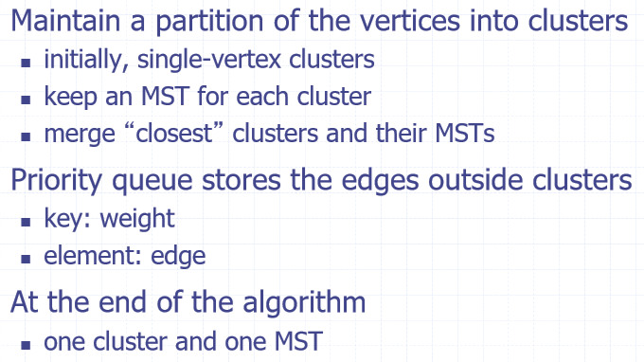

#### Pseudo-Code

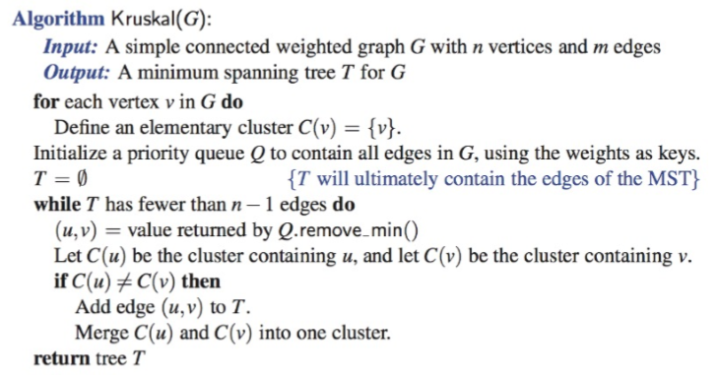

#### Data Structure for Kruskal’s Algorithm

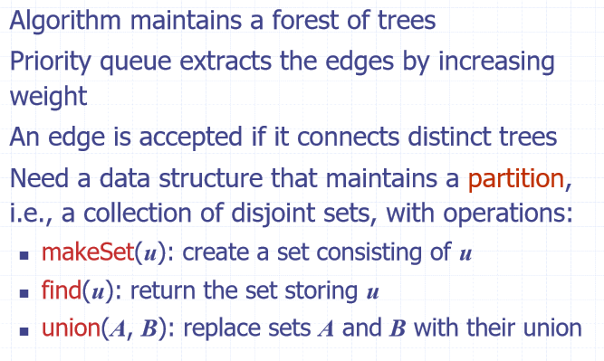

##### List-Based Partition

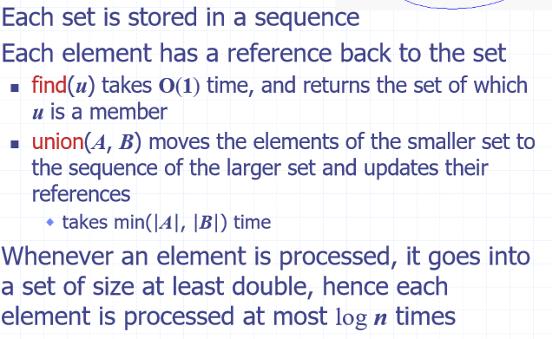

##### Partition-Based Implementation

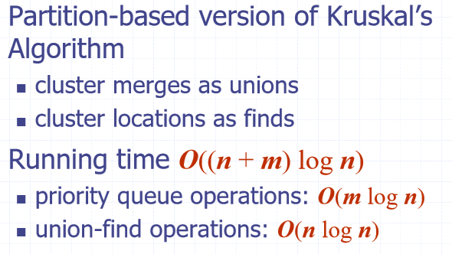

#### Baruvka’s Algorithm

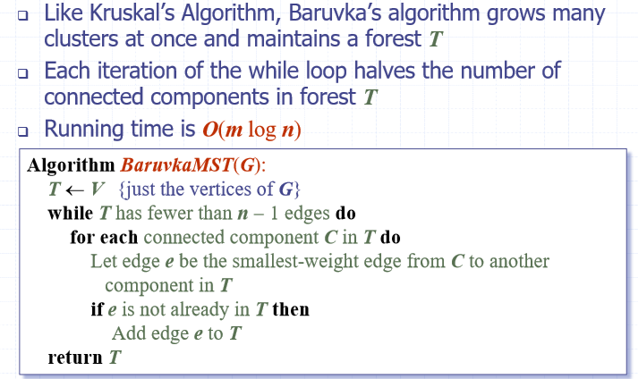

## Week 10

### Brute-Force Pattern Matching

Compare the pattern P with the text T for each possible shift of P relative to T

#### Pseudo-Code

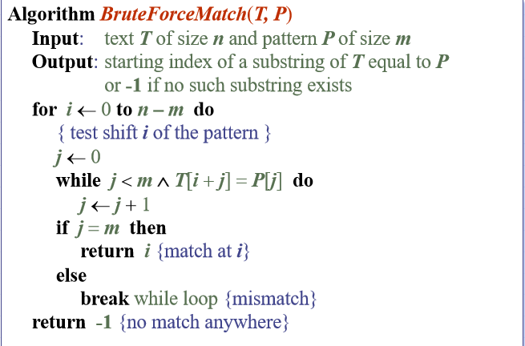

#### Example:

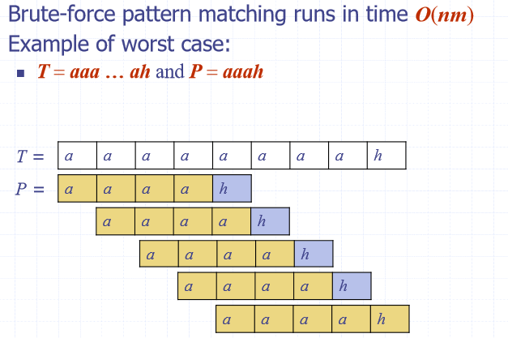

### Boyer-Moore

* Attempts to improve Brute-Force by using two heuristics
  + Looking-glass heuristic – Compare P with a subsequence of T moving backwards
  + Character-Jump heuristic – When a mismatch occurs at T[i] = c:
    - If P contains c, shift P to align with the last occurrence of c in P with T[i]
  + Else:
    - Shift P to align P[0] with T[i+1]

#### Example

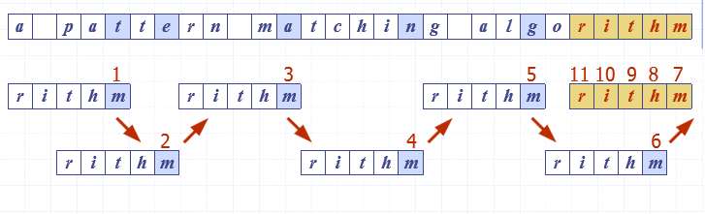

#### Last Occurrence Function

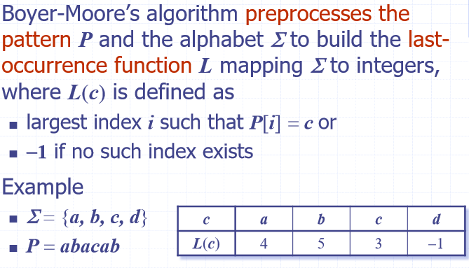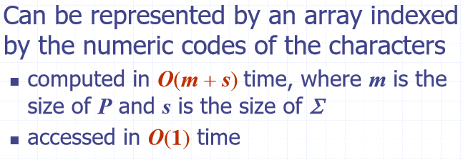

#### Pseudo-Code

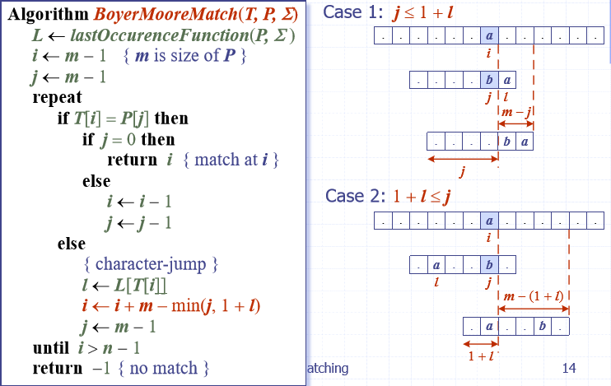

#### Analysis

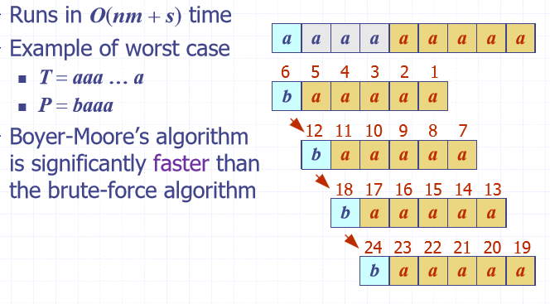

### Knuth-Morris-Pratt (KMP) Algorithm

* Compares pattern to the text, left to right.
* When a mismatch occurs, what is the most we can shift the pattern so we can avoid redundant comparisons? Answer is, the largest prefix of P[0…j-1] that is a suffix of P[1…j-1]

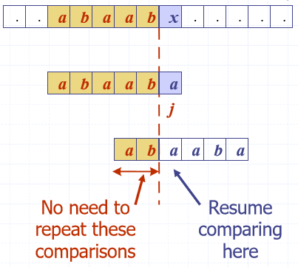

#### Failure Function

* Defined as the size of the largest prefix of P[0…j] that is also a suffix of P[1…j]

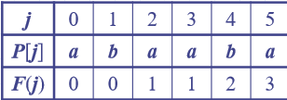

#### Pseudo-Code

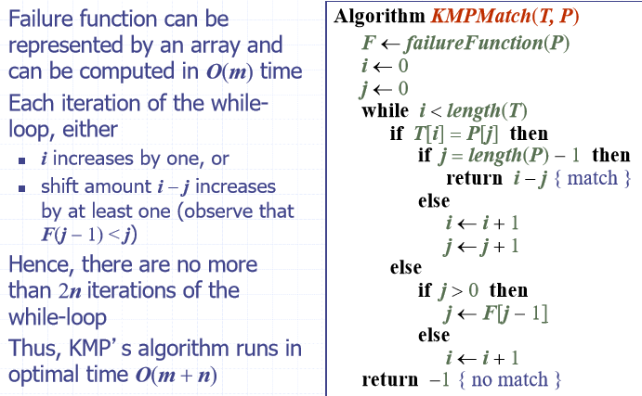

#### Example

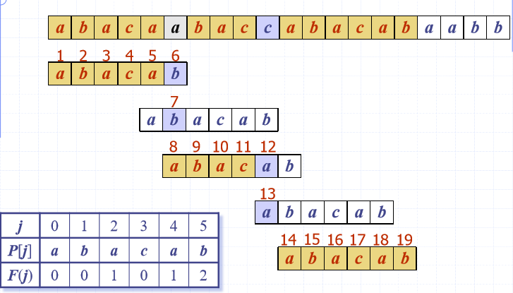

### Tries

Standard trie for a set of strings S is an ordered tree.

* Each node, but the root is labelled with a character
* Children of a node are alphabetically ordered
* Paths from the root to the external nodes yield the strings of S

#### Example

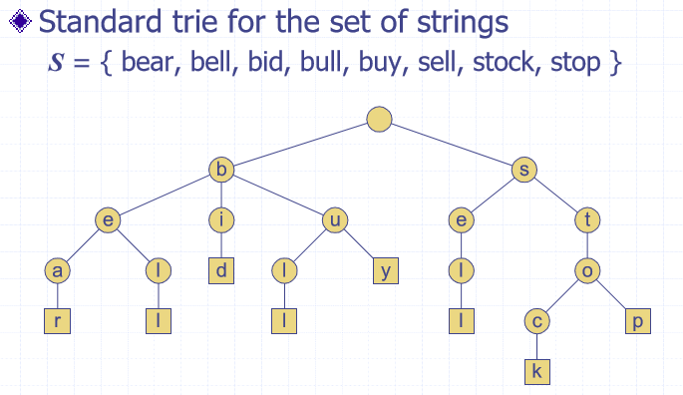

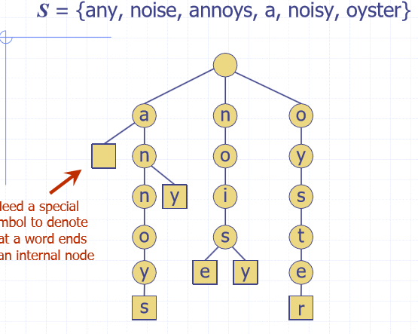

#### Analysis

Let n be the total size of the strings in S, m be the size of the string parameter of the (e.g. search) operation and d be the size of the alphabet. Tries use O(n) space. Supports searches, insertions, and deletions in time O(dm)

#### Word Matching

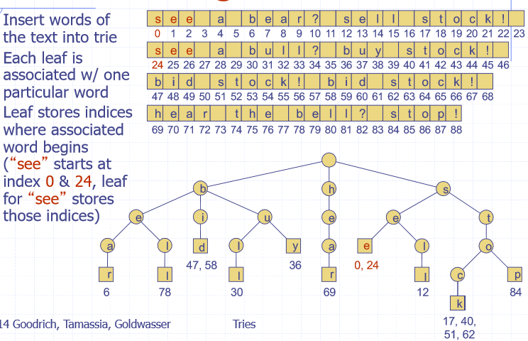

### Compressed Tries

* Has internal nodes of degree at least two
* Obtained from standard trie by compressing chains of redundant nodes.

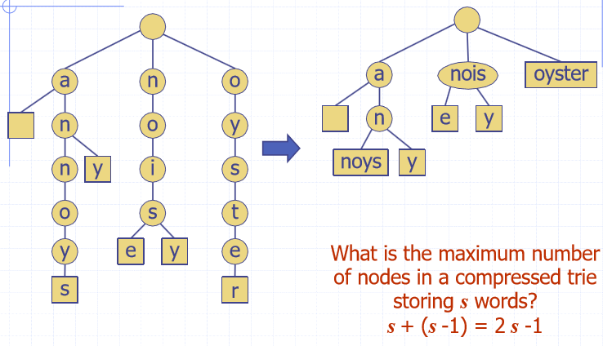

#### Compact Representation

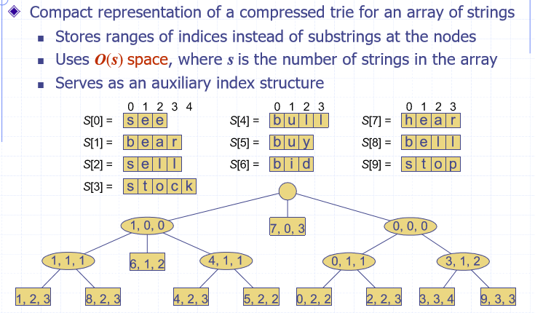

#### Suffix Trie

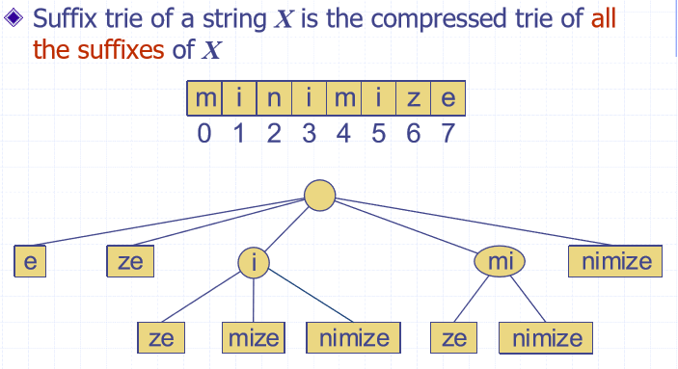

#### Suffix Trie Compact Representation

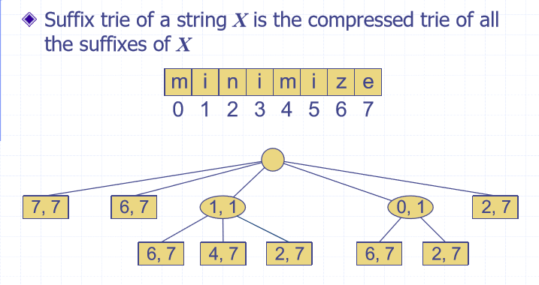

#### Suffix Trie Analysis

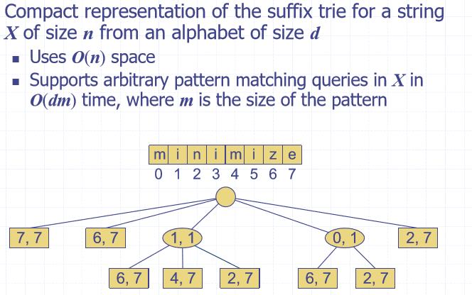

### Text Compression

* We can compress a string X into a smaller string Y by using a prefix code for the characters of X

#### Prefix Code

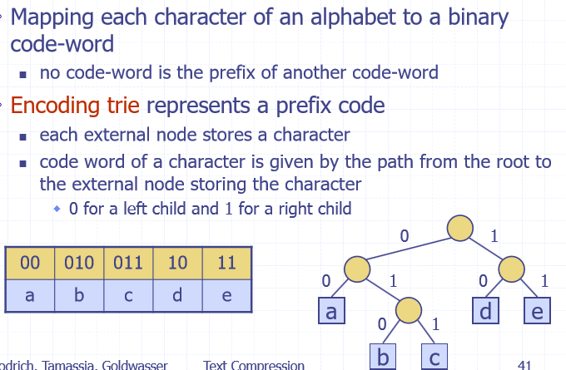

#### Example

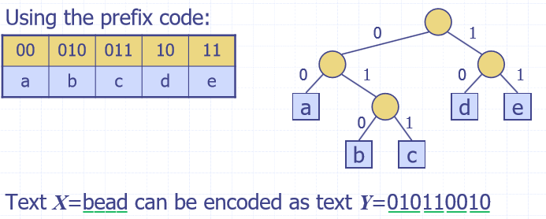

#### Encoding Tree Optimisation

* Frequent characters should have short code-words (i.e. 0 or 1)
* Rare characters should have long code-words

### Huffman’s Algorithm

* Given a string X, construct a prefix code that minimised the size of the encoding of X

#### Pseudo-Code

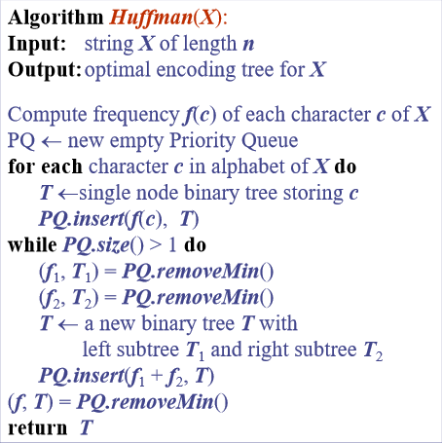

#### Analysis

